|  |  |
| --- | --- |
| 9/23/24, 6:25 AM | IESCO ONLINE BILL |

|  |  |  |  |  |  |  |  |  |  |  |  |  |  |  |  |  |  |  |  |  |  |  |  |  |  |  |  |  |  |
| --- | --- | --- | --- | --- | --- | --- | --- | --- | --- | --- | --- | --- | --- | --- | --- | --- | --- | --- | --- | --- | --- | --- | --- | --- | --- | --- | --- | --- | --- |
| |  |  |  |  | | --- | --- | --- | --- | |  | **ISLAMABAD ELECTRIC SUPPLY COMPANY** | | **IESCO GST No.** | | **26-00-2716-001-91** | | **[www.iesco.com.pk](http://www.iesco.com.pk/)** | | **YOUR BETTER SERVICE - OUR PRIDE** | **ELECTRICITY CONSUMER BILL** | | | | | | | | | | | | | | | | | | | | | | |
| **CONNECTION DATE** | | | | **CONNECTED LOAD** | | | | **ED@** | | **BILL MONTH** | | | **READING DATE** | | | **ISSUE DATE** | | | | **DUE DATE** | |
| 10 MAY 22 | | | |  | | | | 1.5% | | SEP 24 | | | 13 SEP 24 | | | 14 SEP 24 | | | | 30 SEP 24 | |
| **CONSUMER ID** | | | **TARIFF** | | | | **LOAD** | | **OLD A/C NUMBER** | | | | | **DIVISION** | | | TARIQABAD | | | | |
| 1143438000 | | | A-1a(01) | | | | 2 | | 02146221107301 | | | | | **SUB DIVISION** | | | ADIALA | | | | |
| **REFERENCE NO** | | | **LOCK AGE** | | | | **No of ACs** | | **UN-BILL-AGE** | | | | | **FEEDER NAME** | | | 109113 DEFENCE ROAD | | | | |
| 03 14622 1107301 U | | |  | | | |  | |  | | | | | **Web Generated Bill** | | | | | | | |
| **Say No To**  **Corruption** NAME & ADDRESS   |  |  |  | | --- | --- | --- | | ABADUL REHMAN  S/O FAZAL DIN  HILL VIEW LAIN ADYALA RD RWP | |  | | --- | | **Pay your bill through**  **1Link-1Bill by using code 111444 before Electricity bill reference number** | | | | | | | | | | | | | | | | |  |  |  |  | | --- | --- | --- | --- | | **MONTH** | **UNITS** | **BILL** | **PAYMENT** | | | | | | | | |
| Sep23  Oct23  Nov23  Dec23  Jan24  Feb24  Mar24  Apr24  May24  Jun24  Jul24  Aug24 | 199  111  64  36  59  144  107  EX 71  106  139  329  156 | | | | 2794  1652  974  902  1154  2491  2132  4133  1766  2330  16794  5517 | | 2794  1652  974  902  1154  2491  0  4133  1766  2330  16794  5517 |
| **METER NO** | **PREVIOUS READING** | | | | **PRESENT READING** | | **MF** | **UNITS** | | | **STATUS** | | |
| |  |  |  |  |  | | --- | --- | --- | --- | --- | | S-P 2151417 | 2305 | 2434 | 1 | 129 | | | | | | | | | | | | | | |
| **IESCO CHARGES** | | | | | | **GOVT CHARGES** | | | | | | | | |  | | --- | | **TOTAL CHARGES** | | | | | | | | |
| **UNITS CONSUMED** | | 129 | | | | **ELECTRICITY DUTY** | | | | | | 47 | | **ARREAR/AGE** | | | | 0 | | | |
| **COST OF ELECTRICITY** | | 2961 | | | | **TV FEE** | | | | | | 35 | |
| **CURRENT BILL** | | | | 4264 | | | |
| **METER RENT Fix Charges** | |  | | | | **GST** | | | | | | 645 | |
| **BILL ADJUSTMENT** | | | |  | | | |
| **SERVICE RENT** | |  | | | | **INCOME TAX** | | | | | |  | | **INSTALLEMENT** | | | |  | | | |
| **FUEL PRICE**  **ADJUSTMENT** | | -121.47 | | | | **EXTRA TAX** | | | | | |  | |
| **SUBSIDIES** | | | |  | | | |
| **F.C SURCHARGE** | | 416.67 | | | | **FURTHER TAX** | | | | | |  | | **TOTAL FPA** | | | | -145 | | | |
|  | |  | | | |  | | | | | |  | | **PAYABLE WITHIN DUE DATE** | | | | 4119 | | | |
| **QTR TARRIF ADJ/DMC** | | 160.28 | | | | **RETAILER STAX** | | | | | |  | |
| **L.P.SURCHARGE** | | | | 354 | | | |
| **TOTAL** | | 3416.48 | | | |  | | | | | |  | |
| **PAYABLE AFTER DUE DATE** | | | | 4473 | | | |
|  | |  | | | |  | | | | | |  | |
| **Center**   |  |  |  | | --- | --- | --- | | **SDO #** | **Name :** | For complaints dial: | | **ADYALA** | | /03195990622 | 118 /SMS: 8118 | | **Ph # :** |   **5574088**  **BILL CALCULATION**  GOP Tariff x Units  22.9500 X 129  **GST ON FPA**  **ED ON FPA**  **FURTHER TAX ON FPA S.TAX ON FPA**  **IT ON FPA**  **ET ON FPA**  ----------------------------- **TOTAL TAXES ON FPA**  -22 -1.82  `  ----------------------------- -23.82  **TOTAL**  703.18  **DEFFERRED AMOUNT**  Fuel Price Adjustment for Jul-24 @ -0.3692/KWH  **OUTSTANDING INST. AMOUNT**  **PROG. GST PAID F-Y**  **PROG. IT PAID F-Y** | | | | | | | | | | | | | | | | | | | | | |
|
|
|
|
|
|
|
|  | | | | | | | | | | | | | | | | | | | | | |

https://bill.pitc.com.pk/iescobill/general?refno=03146221107301 1/2

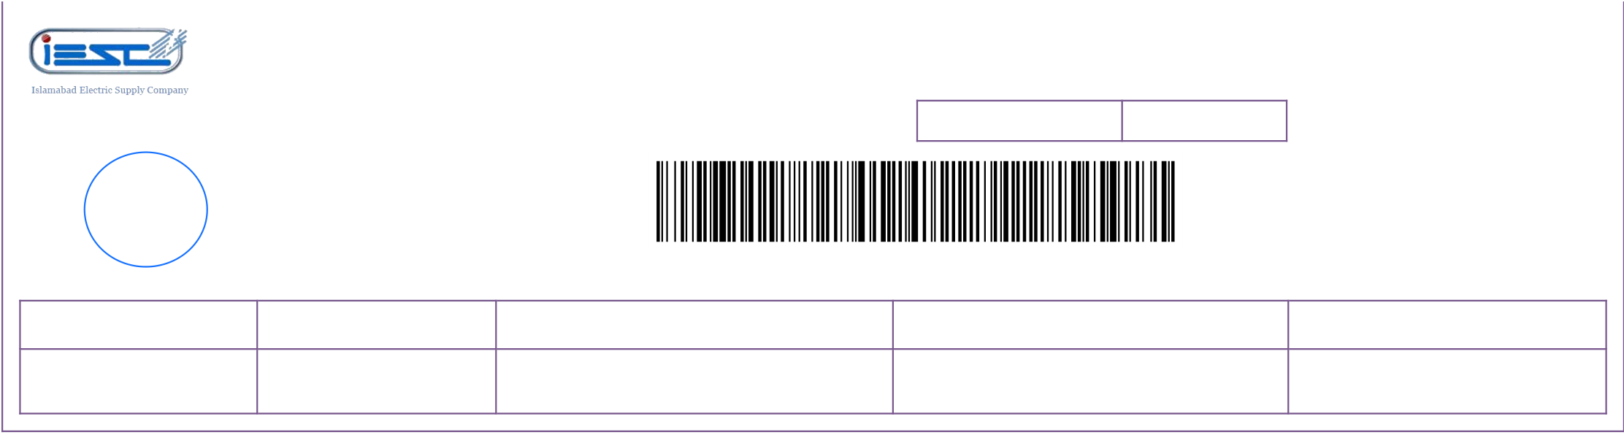

|  |  |  |  |  |
| --- | --- | --- | --- | --- |
| 9/23/24, 6:25 AM | IESCO ONLINE BILL | | | BILL NO |
| **www.iesco.com.pk** | ISLAMABAD ELECTRIC SUPPLY COMPANY - ELECTRICITY | | |
| CONSUMER BILL | | |
| 1 |
| **YOUR BETTER SERVICE - OUR PRIDE** | **CONSUMER ID** | 1143438000 |

BANK

STAMP

SEP 24 - 03 14622 1107301 - 000004119 - 30 SEP 24 - 6

|  |  |  |  |  |  |  |
| --- | --- | --- | --- | --- | --- | --- |
| **BILL MONTH** | **DUE DATE** | **REFERENCE NO** | | **PAYABLE WITHIN DUE DATE** | 4119 | 2/2 |
| SEP 24 | 30 SEP 24 | | 03 14622 1107301 U | **PAYABLE AFTER DUE DATE** | 4473 |
| https://bill.pitc.com.pk/iescobill/general?refno=03146221107301 | | | |